Polytechnic University of the Philippines

**COLLEGE OF COMPUTER AND INFORMATION SCIENCES**

A. Mabini Campus, Sta. Mesa, Manila

**

***e-Ventory: Event Management System***

In partial fulfillment of the requirements for the courses:

**COMP 2113 – ADVANCED PROGRAMMING**

**COMP 4023 – DATABASE ADMINISTRATION**

**INTE 3033 – DATABASE MANAGEMENT SYSTEMS 2**

*Alano, Bryan Julius A.*

*Canada, Kenneth H.*

*Pepino, John Roderick T.*

*Samonte, Ryan Joseph R.*

*Vasquez, Lowell Jay F.*

Proponents

*October 25, 2017*

**Executive Summary**

Nowadays, when technologies are helping humans in their daily lives. Some people don't use it to their advantage like some event planners who manually organize small or big events such as concerts, debuts, seminars and etc. which takes too much time to organize.

The proponents tend to make a system that will help the Event Planners to organize it automated and using social media especially Facebook to post the events online. The system will produce a QR Verification Code for the tickets to know if the tickets are legitimate or not.

Likewise, with the participants who don’t like to stand and wait for hours in long lines in order to get a ticket in the event and booked it online. The proponents will make it through online to get a ticket for the event.

**Table of Contents**

**Title Page**

**Executive Summary**

**PART I – PROJECT SPECIFICATIONS REPORT 4**

**1.1. INTRODUCTION 4**

**1.2. STATEMENT OF THE PROBLEM 4**

**1.3. PROJECT OBJECTIVES 5**

**1.3.1. General Objectives 5**

**1.3.2. Specific Objectives 5**

**1.4. SCOPE AND LIMITATION 5**

**1.5. PROJECT ASSUMPTIONS 5**

**PART II – DATABASE SPECIFICATIONS REPORT 6**

**2.1. BUSINESS RULES 6**

**2.2. ENTITY-RELATIONSHIP DIAGRAM 7**

**2.3. NORMALIZED RELATIONS 9**

**2.4. DATA DICTIONARY 10**

**2.5. DATABASE DIAGRAM 14**

**PART III – APPLICATION SPECIFICATIONS REPORT 15**

**3.1. APPLICATION DESCRIPTION 15**

**3.2. PROSPECT USERS OF THE SYSTEM 15**

**3.3. FEATURES SPECIFICATION 15**

**3.4. APPLICATION SCREENSHOTS 19**

# **PART I – PROJECT SPECIFICATIONS REPORT**

## **INTRODUCTION**

Nowadays, Events are being held around the world. We do like go to events such as weddings, concerts, meetings, and the likes that will leave a mark on our memory and will be a treasure in the rest of our lives.

Some of the event planners manually do the planning process and promoting of events that results a much-needed time involved. Moreover, they didn’t use the new technologies in their work like using Facebook in terms of posting event announcements. The tickets don't have QR verification codes that will tell if the tickets are legitimate.

On the other hand, sometimes the participants must register manually and nowadays people don’t like to waste their time on manual processes and they like to do it easily to lessen the time and effort.

The proponents tend to make a system that can do the following: Create an event, announcements through Facebook, manage events registration, participant’s information and payment that would make it convenient for them.

This system will help the event planners to easily organize events in a much shorter span of time and a much efficient way as possible.

## **1.2. STATEMENT OF THE PROBLEM**

Organizer cannot handle the number of participants due to manual process of ticket verification and registration and the organizers manually announce the details of the events so that it becomes less efficient.

* The tickets don’t have QR Verification code.
* The organizers can’t recognize if the ticket is legitimate or not.

## **1.3. PROJECT OBJECTIVES**

### **1.3.1. General Objectives**

The organizers manually manage their events so we come up with a solution to help them easily manage their held events.

### **1.3.2. Specific Objectives**

Organizing events manually, especially big events is difficult and time–consuming. This system called e-Ventory will help them manage events easily and post it through Facebook, to produce a QR Verification Code for the tickets.

## **1.4. SCOPE AND LIMITATION**

The system can add, update, delete, and search events. It can also post the details or announcements about the events on Facebook group and can produce a QR Code for the tickets and payment voucher. The system can’t update the admin account information, printing of receipts and, multiple tickets functionality for each participant.

## **1.5. PROJECT ASSUMPTIONS**

* *One time sign up of participants.*
* *Statistics about the events.*

# **PART II – DATABASE SPECIFICATIONS REPORT**

## **2.1. BUSINESS RULES**

|  |  |
| --- | --- |
| Rule ID | Business Rule |
| BR_001 | EACH EVENT HAS LIMITED CAPACITY |
| BR_002 | EVENTS CAN HAVE MANY SCHEDULE |
| BR_003 | EACH EVENT HAS ONE VENUE |
| BR_004 | EACH EVENT HAS TICKET |
| BR_005 | EACH PARTICIPANT HAS INFORMATION |
| BR_006 | PARTICIPANT HAS ADMIN |
| BR_007 | EACH PARTICIPANT HAS PAYMENT STATUS |
| BR_008 | ADMIN MUST HAVE A FB ACCOUNT |
| BR_009 | EACH TICKET HAS EVENT’S SCHEDULE INFORMATION |
| BR_010 | QR CODE CAN BE CLASSIFFY AS QR TICKET OR QR VOUCHER |

## **2.2. ENTITY-RELATIONSHIP DIAGRAM**

Chen’s Notation

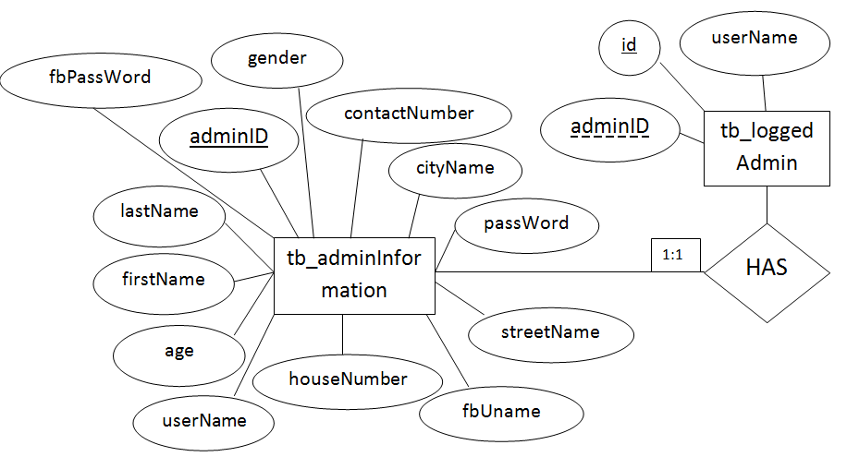

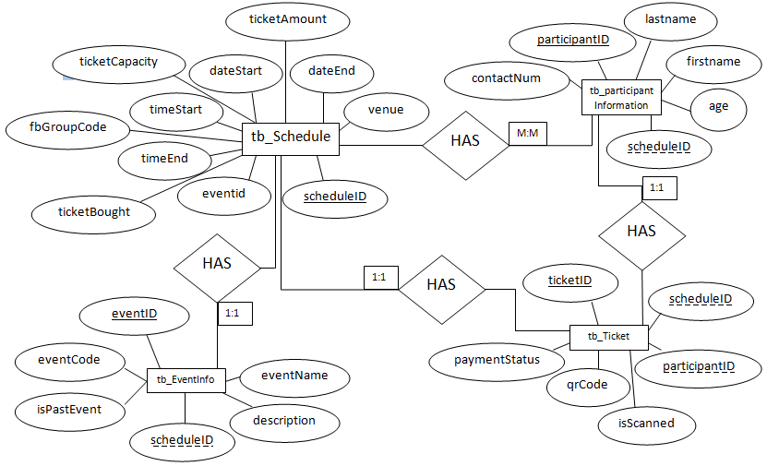

Crow’s Foot

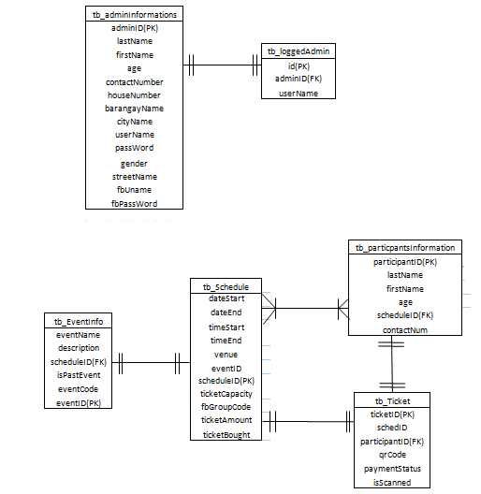

## **2.3. NORMALIZED RELATIONS**

3rd Normal Form

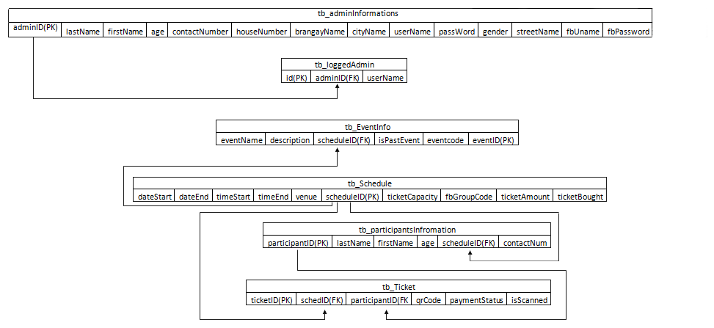

## **DD1.PNG2.4. DATA DICTIONARY**

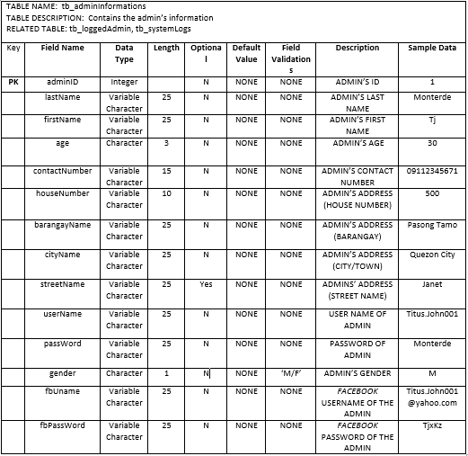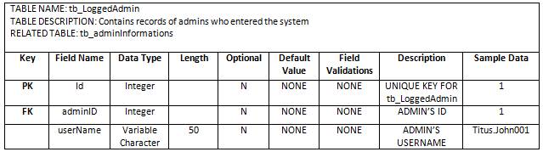

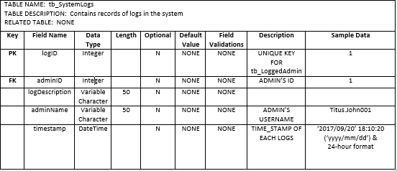 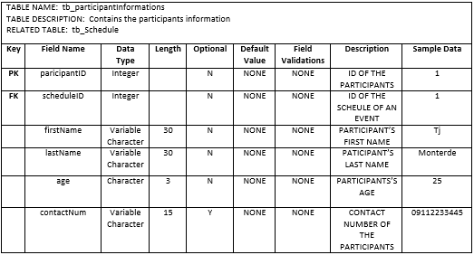

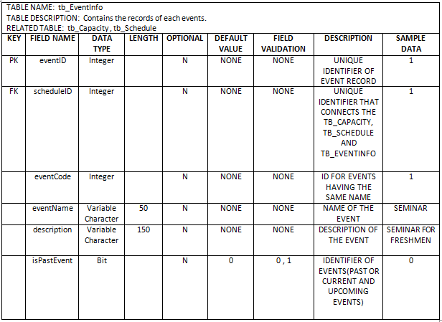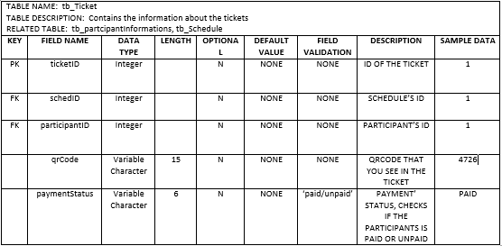

## **2.5. DATABASE DIAGRAM**

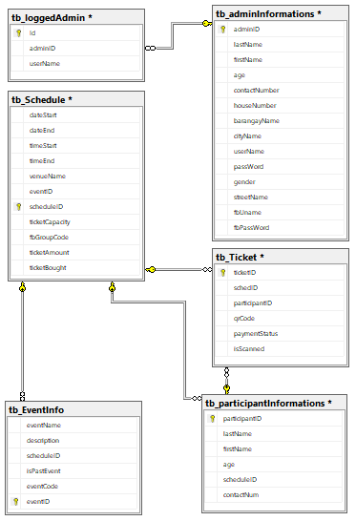

# 

# **PART III – APPLICATION SPECIFICATIONS REPORT**

## **3.1. APPLICATION DESCRIPTION**

The e-Ventory is a management system that will help organizers organize events automated and that will save time in managing an event. The said system will post the events and announcements through fb and will produce a QR Verification Code for the tickets to tell if the tickets are legitimate.

## **3.2. PROSPECT USERS OF THE SYSTEM**

* Event Organizers who organize events such as debuts, weddings, concerts, meetings, seminars and etc.

## **3.3. FEATURES SPECIFICATION**

|  |  |  |
| --- | --- | --- |
| Feature ID: | | Feat-001 |
| Feature Name: | | Accounts |
| Business Rule ID: | | BR_008 |
| User Story: | | |
| 1. | *A user should be able to create accounts and log in to the system.* | |

|  |  |  |
| --- | --- | --- |
| Feature ID: | | Feat-002 |
| Feature Name: | | Add event |
| Business Rule ID: | | BR_003 |
| User Story: | | |
| 1. | *A user should be able to add events.* | |

|  |  |  |
| --- | --- | --- |
| Feature ID: | | Feat-003 |
| Feature Name: | | Update event |
| Business Rule ID: | | BR_003 |
| User Story: | | |
| 1. | *A user should be able to update events.* | |

|  |  |  |
| --- | --- | --- |
| Feature ID: | | Feat-004 |
| Feature Name: | | Delete event |
| Business Rule ID: | | BR_003 |
| User Story: | | |
| 1. | *A user should be able to delete events.* | |

|  |  |  |
| --- | --- | --- |
| Feature ID: | | Feat-005 |
| Feature Name: | | Search event |
| Business Rule ID: | | BR_001, BR_002, BR_003, BR_004 |
| User Story: | | |
| 1. | *A user should be able to search events.* | |

|  |  |  |
| --- | --- | --- |
| Feature ID: | | Feat-006 |
| Feature Name: | | Facebook group announcement |
| Business Rule ID: | | BR_008 |
| User Story: | | |
| 1. | *A user should be able to announce on Facebook about the details of events.* | |

|  |  |  |
| --- | --- | --- |
| Feature ID: | | Feat-007 |
| Feature Name: | | Registration of Participants |
| Business Rule ID: | | BR_005, BR_006, BR_007 |
| User Story: | | |
| 1. | *A user should be able to register participants.* | |

|  |  |  |
| --- | --- | --- |
| Feature ID: | | Feat-008 |
| Feature Name: | | Ticket Payment |
| Business Rule ID: | | BR_007 |
| User Story: | | |
| 1. | *A user should be able to view the paid or unpaid participants.* | |

|  |  |  |
| --- | --- | --- |
| Feature ID: | | Feat-009 |
| Feature Name: | | QR Code |
| Business Rule ID: | | BR_009, BR_010 |
| User Story: | | |
| 1. | *A user should be able to produce a QR Code for the tickets.* | |

|  |  |  |
| --- | --- | --- |
| Feature ID: | | Feat-010 |
| Feature Name: | | Dashboard |
| Business Rule ID: | | BR_008 |
| User Story: | | |
| 1. | *A user should be able to see the* number of events, upcoming events, number of registered admins and the number of participants. | |

|  |  |  |
| --- | --- | --- |
| Feature ID: | | Feat-011 |
| Feature Name: | | System Logs |
| Business Rule ID: | | BR_005, BR_006 |
| User Story: | | |
| 1. | The user will be able to see the admins who create, update, delete an event. | |

|  |  |  |
| --- | --- | --- |
| Feature ID: | | Feat-012 |
| Feature Name: | | System Logs |
| Business Rule ID: | | BR_005 |
| User Story: | | |
| 1. | The user will be able to see the participants who paid in a specific event. | |

|  |  |  |
| --- | --- | --- |
| Feature ID: | | Feat-013 |
| Feature Name: | | Ticket Scanner |
| Business Rule ID: | | BR_004 |
| User Story: | | |
| 1. | The user will be able to scan the tickets. | |

|  |  |  |
| --- | --- | --- |
| Feature ID: | | Feat-014 |
| Feature Name: | | Online Registration |
| Business Rule ID: | | BR_007 |
| User Story: | | |
| 1. | The participants will be able to register online. | |

## **3.4. APPLICATION SCREENSHOTS**

|  |  |
| --- | --- |
| Form Name: | Log-In Frame |
| Description: | The user must enter the correct username and password to log in. |
| Feature ID: | Feat-001 |

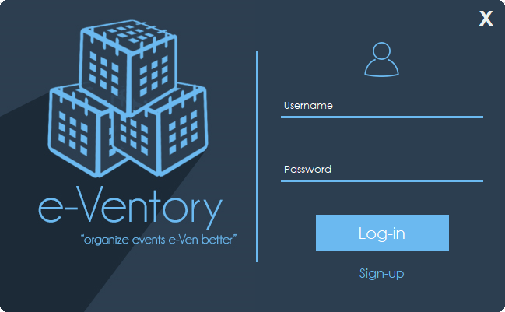

Figure 1.0. Log In Frame

|  |  |
| --- | --- |
| Form Name: | Sign-up |
| Description: | The user will be able to sign up. |
| Feature ID: | Feat-012 |

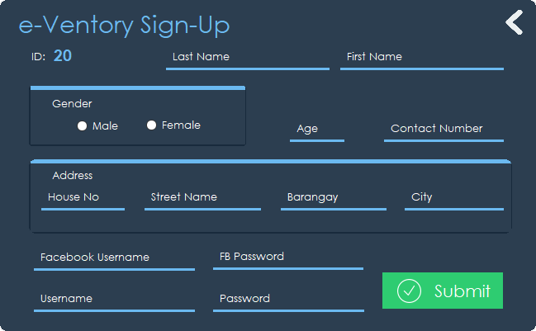

Figure 2.0. Sign-Up

|  |  |
| --- | --- |
| Form Name: | Dashboard |
| Description: | The user will see the number of events, upcoming events, number of registered admins and the number of participants. |
| Feature ID: | Feat-001 |

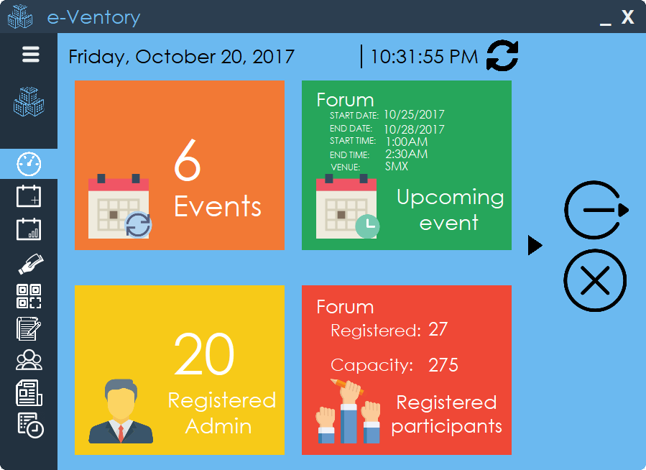

Figure

Figure 3.0. Dashboard

|  |  |
| --- | --- |
| Form Name: | Add Event |
| Description: | The user will be able to add events. |
| Feature ID: | Feat-002 |

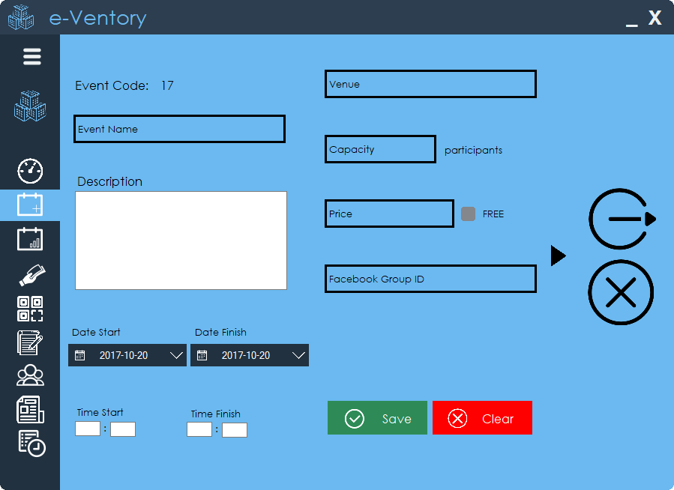

Figure 2.0. Dashboard

Figure 4.0. Add Event

|  |  |
| --- | --- |
| Form Name: | Monitor Event |
| Description: | The user will be able search the event, update and delete an event. |
| Feature ID: | Feat-003, Feat-004, Feat-005 |

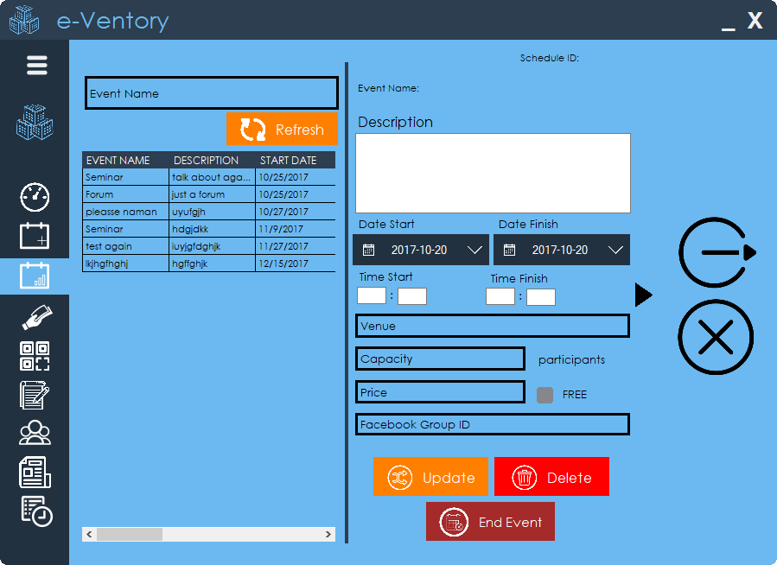

Figure 2.0. Dashboard

Figure 5.0. Monitor Event

|  |  |
| --- | --- |
| Form Name: | Announcement |
| Description: | The user will be able post the announcements on Facebook. |
| Feature ID: | Feat-006 |

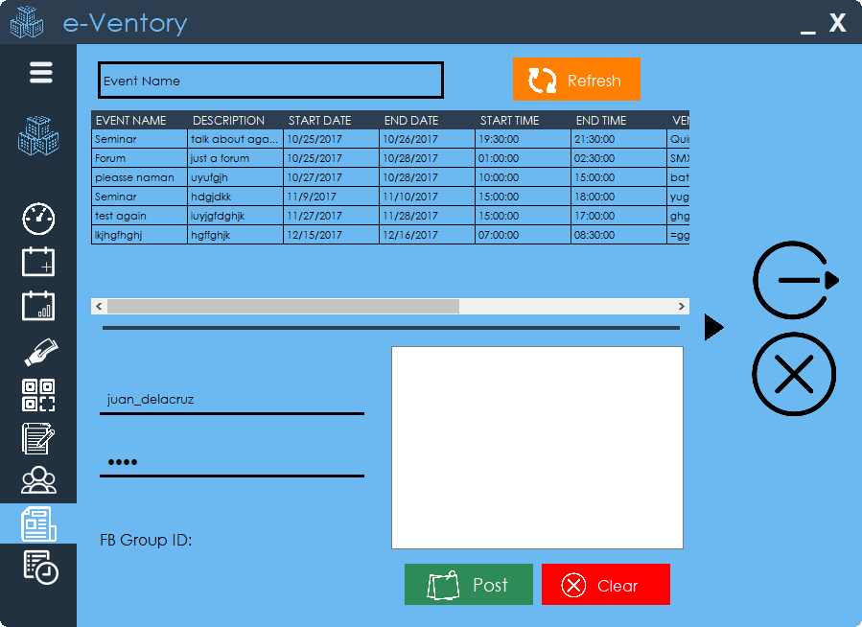

Figure 2.0. Dashboard

Figure 6.0. Announcement

|  |  |
| --- | --- |
| Form Name: | Registration |
| Description: | The user will be able register into an event. |
| Feature ID: | Feat-007 |

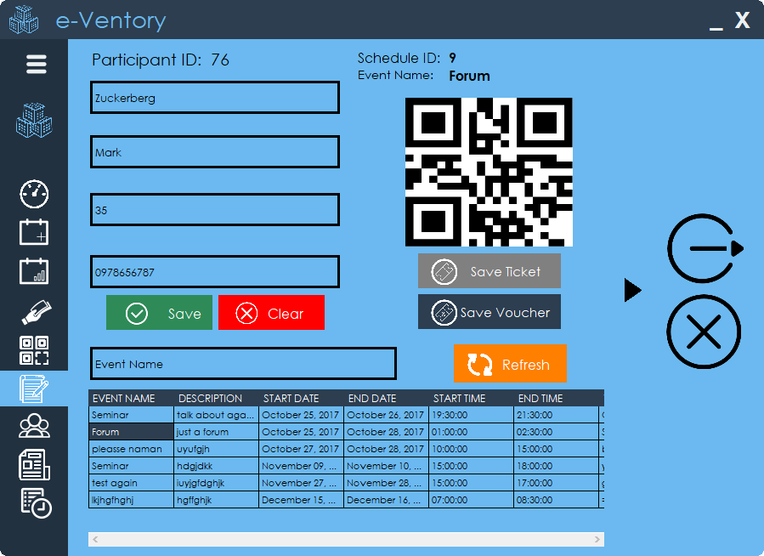

Figure 2.0. Dashboard

Figure 7.0. Registration

|  |  |
| --- | --- |
| Form Name: | Payment |
| Description: | The user will be able to scan the QR Code and make a payment transaction. |
| Feature ID: | Feat-007, Feat-008 |

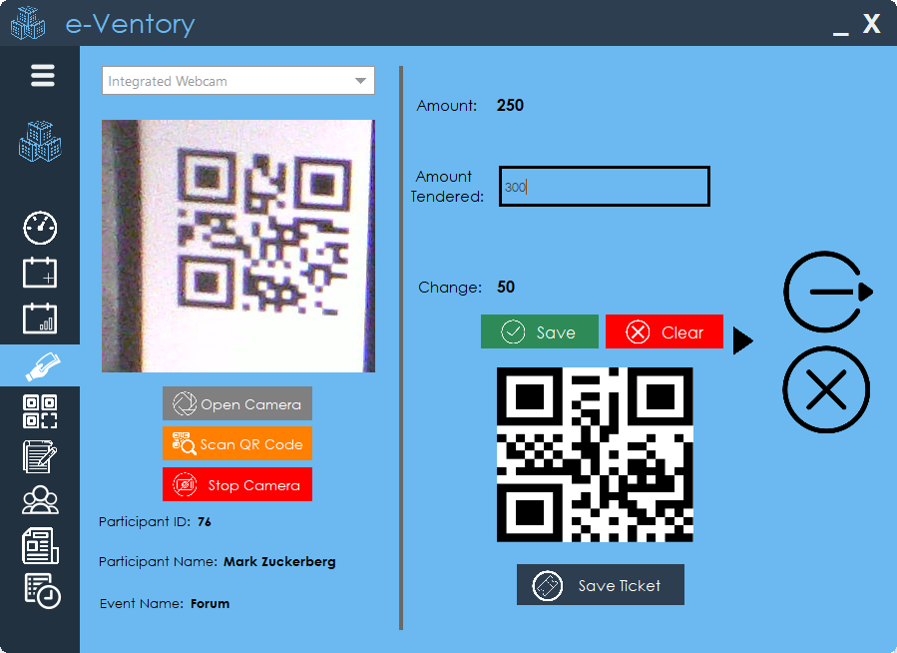

Figure 8.0. Payment

|  |  |
| --- | --- |
| Form Name: | Participant |
| Description: | The user will be able to see the participants in a specific event. |
| Feature ID: | Feat-012 |

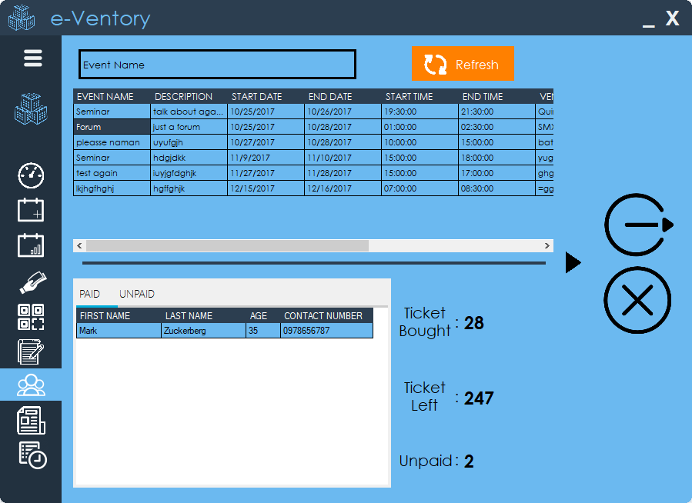

Figure 9.0. Participant

|  |  |
| --- | --- |
| Form Name: | Ticket Scanner |
| Description: | The user will be able to scan the tickets. |
| Feature ID: | Feat-013 |

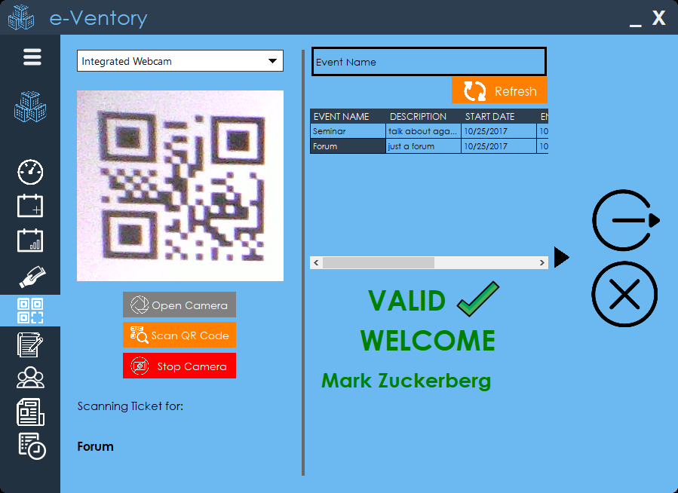

Figure 10.0. Ticket Scanner

|  |  |
| --- | --- |
| Form Name: | Ticket Scanner (if scanned already) |
| Description: | The user will be able to see if the ticket if the tickets is scanned already. |
| Feature ID: | Feat-013 |

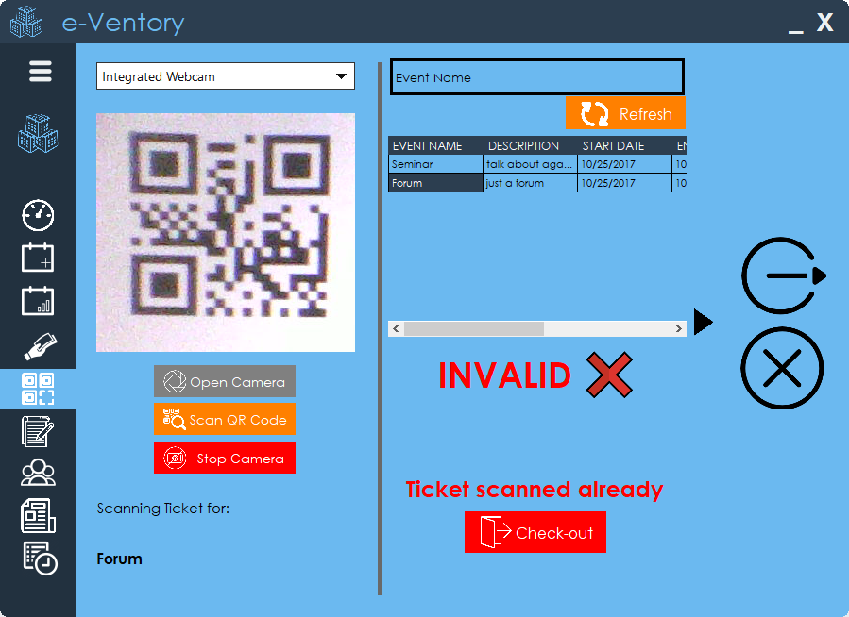

Figure 10.0. Ticket Scanner (if scanned already)

|  |  |
| --- | --- |
| Form Name: | System Logs |
| Description: | The user will be able see the admins who logged in into the system. |
| Feature ID: | Feat-011 |

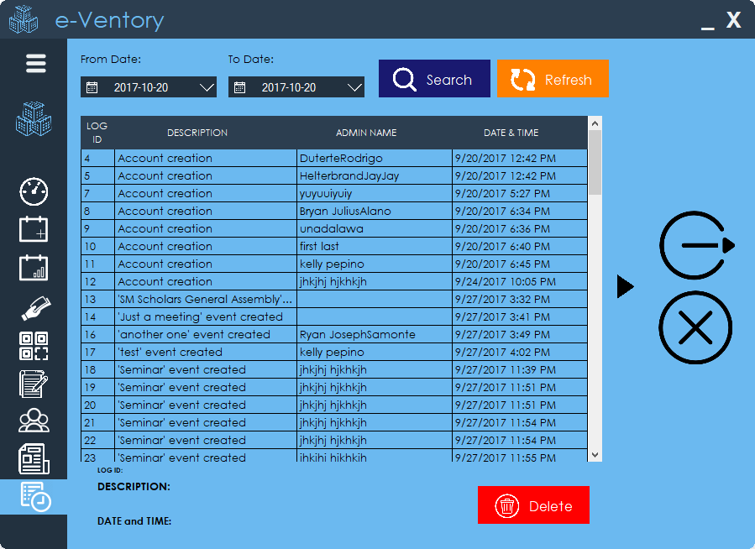

Figure 11.0. System Log

|  |  |
| --- | --- |
| Form Name: | Home Tab Registration |
| Description: | The participants will be able to register online. |
| Feature ID: | Feat-014 |

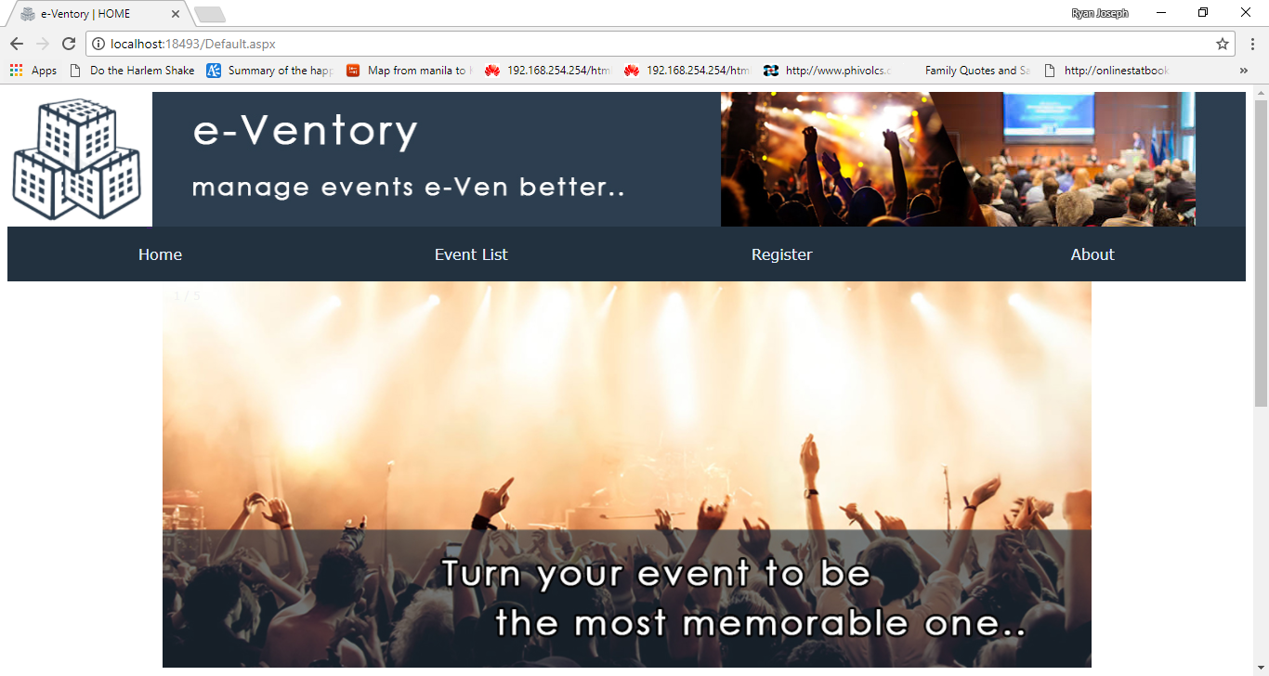 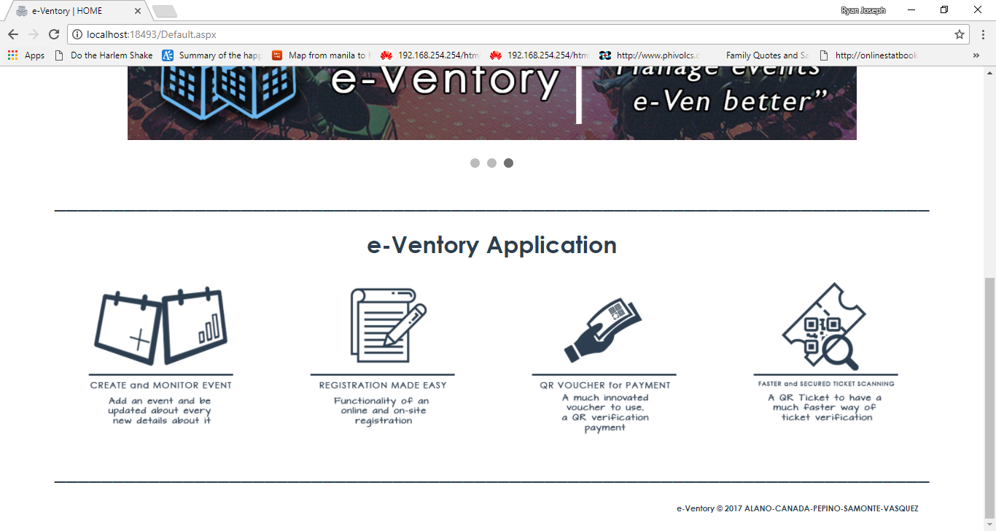



Figure 12.0. Home Tab Registration

|  |  |
| --- | --- |
| Form Name: | Event List Tab |
| Description: | The user will be able see the list of events. |
| Feature ID: | Feat-014 |

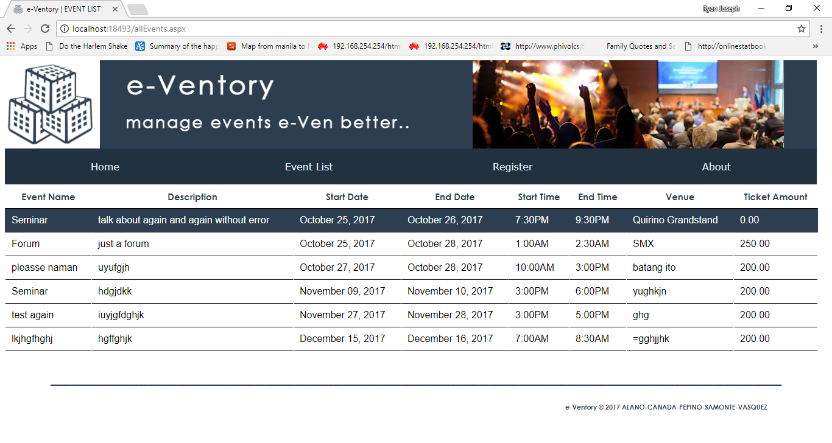

Figure 13.0. Event List Tab

|  |  |
| --- | --- |
| Form Name: | Registration Tab |
| Description: | The participants will be able to register online. |
| Feature ID: | Feat-014 |

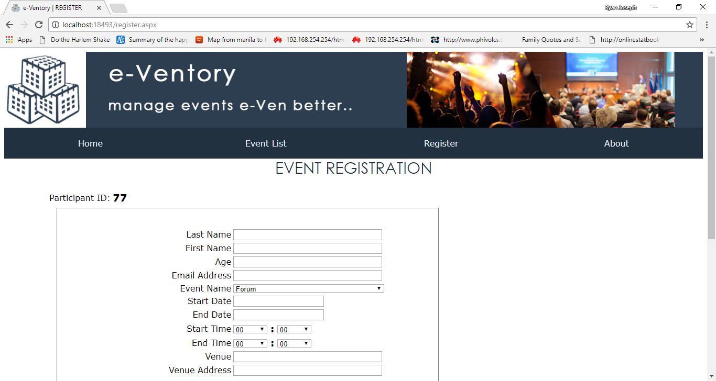

Figure 14.0. Event List Tab

|  |  |
| --- | --- |
| Form Name: | About Tab |
| Description: | The participants will be able to see the description of the system and the proponents. |
| Feature ID: | Feat-014 |

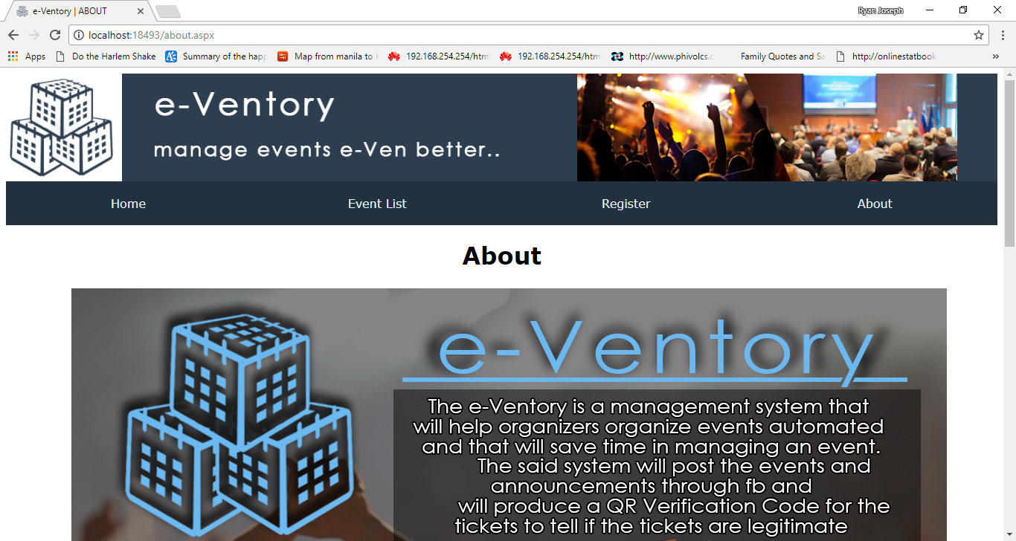 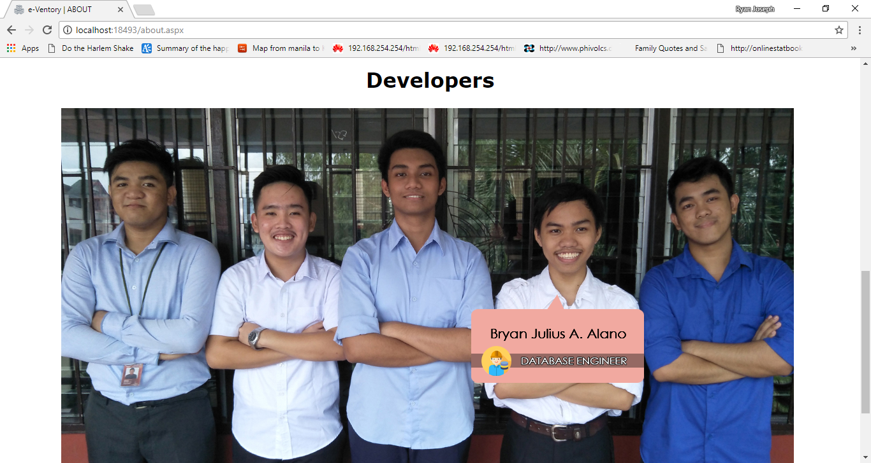

Figure 14.0. Event List Tab